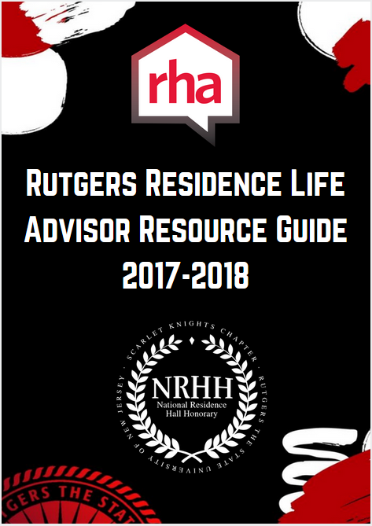
Rutgers Residence Life
Advisor Resource Guide
2017-2018

Residence Hall Association

FAQ’s and Table of Contents

RHA Mission Statement:
RHA’s Guiding Philosophy:
RHA Advisor Philosophy:
What is Residence Hall Association?
Organization Chart
Who can become a member of RHA?
Organization Composition:
Executive Committee Position Descriptions
Meetings
Residential Council
Advocacy Council
Hall Government Position Descriptions
RLC/Grad Direct Advisor Expectations:
RLC Supervisor of Grad Advisor Expectations:
Hall Government Director Advisor Responsibilities
Hall Government 2017 Fall Recruitment Timeline
Important Dates For RHA Election/Recruitment:
Recruitment Tips
Hall Government Interest/Recruitment Letter
Hall Government Info Session Meeting Agenda Template
Advising Do’s
Advising Dont’s
Motivating Others
Retention of Members
Group Development and the use of Tuckman
Important Events

RHA Mission Statement:
The Rutgers Residence Hall Association (RHA) aims to improve the residential experience for on-campus students through intentional programming and feedback-based advocacy initiatives while fostering the person growth and leadership development of its members.
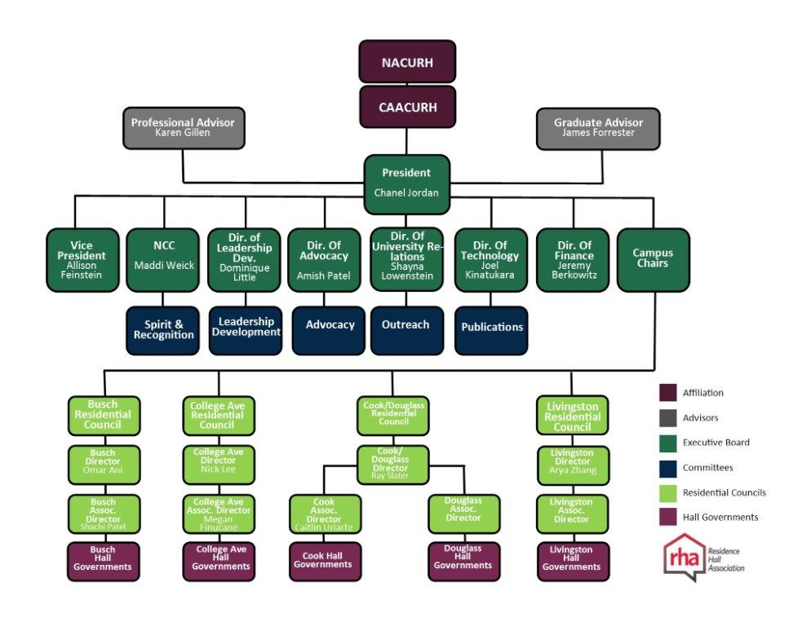
RHA’s Guiding Philosophy:
There are three tiers within the Rutgers RHA structure.
Tier 1: The Executive Board and General Assembly is the upper RHA organization and focuses on being the university representative for on campus students, focused on advocacy, and being the liaison with other university entities.
Tier 2: There is a Residential Council for each campus and is comprised of that campus’s Vice Presidents. This group focuses on programming and community development for that particular campus population and serves as the source for that campus’s student advocacy.
Tier 3: The Hall Governments are the foundation of RHA as there is a Hall Government for each residential hall. This group focuses on developing community within their hall and acting as the student leaders for their hall community. These organizations are a way to gather the student voice while also disseminating information to the community they serve. Each Hall Government’s President and Vice President are the vehicles for connecting their individual hall to the university and campus, respectively.
RHA Advisor Philosophy:
When considering the programming, community development, and advocacy goals for RHA, the advisors focus on the leadership development of the RHA members to help achieve those goals. Advisor work alongside the students in all decision making and planning processes. We are not “hands off” advisors, but are participatory and engaging. We provide growth through the continuous balance of intentional challenge and support. In order to provide a safe environment for our student leaders to learn, we provide guidance and direction without harming their overall development. And by keeping our students aware of policies and procedures, we are able to give them structured autonomy.
What is Residence Hall Association?
The Residence Hall Association (RHA) is made up of 36 Hall Governments, four Residential Campus Councils, and an Executive Board that represents over 16,000 on-campus students. RHA’s mission is to improve the residential experience for on-campus students through programming and feedback-based advocacy initiatives while fostering the personal growth and leadership development of its members. We strive to improve your on-campus living experience while uniting the residential population at Rutgers by being the voice of our residents.

Who can become a member of RHA?
Any on-campus student can be a member of RHA. These members must be in good academic and judicial standing with the university in order to attain a position within the organization. Furthermore, if a student chooses to become involved in RHA they must also maintain a cumulative GPA of 2.5 or higher.

Organization Composition:
RHA is organized to maximize the flow of information from the Executive Board through to the hall governments. Each hall governments have a representative on their campus’s residential council and on the general assembly. The contact information for each Executive Board member is included below

Executive President Director of Technology
Chanel Jordan Joel Kinatukara
rurhapresident@gmail.com ru.rha.techdirector@gmail.com

Executive Vice President Director of University Relations
Allison Feinstein Shayna Lowenstein
rurhavicepresident@gmail.com ru.rha.univrelations@gmail.com

National Communications Coordinator Professional Advisor
Maddi Weick Karen Gillen
rurhancc@gmail.com karen.gillen@rutgers.edu

Director of Finance Graduate Advisor
Jeremy Berkowitz James Forrester
rurhafinance@gmail.com james.forrester@echo.rutgers.edu

Director of Leadership Development
Dominique Little
rurha.leadership@gmail.com

Director of Advocacy
Amish Patel
rurhaadvocacy@gmail.com

Executive Committee Position Descriptions

Executive President
The Executive President role is to preside over all RHA Executive Board meetings, represent RHA to the greater university community, serve as the official contact and liaison of the Residence Hall Association and the RHA Executive Board, oversee all RHA endeavors and assure goals are being achieved Develop Executive Board agendas and oversee financial guidelines and processes, and preside over all General Assembly meetings

Executive Vice President
The Executive Vice President’s is responsible for facilitating communication between all levels of RHA through retreats, emails, Sakai, events and other needed opportunities, coordinate Executive Board retreats in association with the Executive President to foster teamwork and communication between existing Executive Board members and, in the Spring semester, between newly elected Executive Board members, assume presidential responsibilities in absence of the Executive President, take attendance and accurate minutes of all Executive Board and General Assembly meetings Distribute copies of minutes from all four (4) Campus Council meetings, General Assembly meetings, and Executive Board meetings to identified individuals within three (3) business days.

National Communications Coordinator (NCC)
The National Communications Coordinator is responsible for outside correspondence on a campus level, regional level with the Central Atlantic Affiliate of College and University Residence Halls (CAACURH) and national level with the National Association of College and University Residence Halls (NACURH), oversee RHA election processes, arrange and head conference delegations, update the National Information Center (NIC) files as needed Represent Rutgers University at all regional CAACURH and national NACURH events, communicate information received through campus correspondence and provide information on state, regional and national conferences, serve as the liaison between NRHH and RHA.

Director of Finance
The Director of Finance is responsible for creating and presenting an initial budget proposal to the RHA Advisor(s) and other Executive Board members prior to the Fall academic year, maintain updated, accurate files of all past and current RHA business, including but not limited to a public copy of the budget, copies of receipts, and signed forms, and a list of all transactions Responsible for bi-monthly audits of all RHA budgets or as requested Oversee development of budget allocations with the collection of signed care package slips

Director of Leadership Development
The Role of the Director of Leadership Development is to oversee the Leadership Development committee, Plan and oversee fall and spring Leadership Development Day Plan and oversee annual RHA End-of-Year Banquet Plan and oversee other leadership development sessions and opportunities throughout the academic year

Director of Advocacy
The responsibilities of the Director of Advocacy is to oversee Advocacy Committee during GA/Campus Council, identify University wide and specific hall issues, appoint campus or University wide representation or represent RHA to campus constituencies including, but not limited, to Housing, Dining Services, Facilities, Department of Transportation Services, compile points of contact to university departments, distribute contact information to individuals via Google Drive, survey student satisfaction and need through the use of survey instruments of focus groups, explore and coordinate opportunities for town hall meetings.

Director of Technology
The role of the Director of Technology includes maintaining the RHA website at least once (1) per day, create, publish, and distribute informative documents and other promotional materials to the public (RHA Newsletter, flyers, website, etc.) maintain Google Drive, Google email accounts and other technologies utilized by the Executive Board Oversee all technological needs and demands during meetings, events, etc. Work closely with the Director of University Relations to create documents, flyers, posters, etc. for all publicity events/needs Manage all RHA social media platforms Update social media platforms on a daily basis for hall government, Residential Council, Campus Council, GA, and Executive Board events.

Director of University Relations
The responsibilities of the Director of University Relations includes oversee the Outreach Committee, inform the University on what RHA is and what it does Provide publicity for all RHA events (press releases, advertisements, posters, etc.) Present a professional, beneficial and influential image of the organization to the public, create all RHA promotional flyers, lanyards, products, t-shirts with the Director of Technology, update social media platforms on a daily basis for hall government, Residential Council, Campus Council, GA, and Executive Board events

Residential Council Directors
The Residential Council Directors presides over their respective Campus Residential Council meetings Represent RHA to the campus in which associated, oversee all campus-based RHA endeavors and assure goals are being achieved, oversee development of Residential Council budget allocations in coordination with Residential Council Associate Director, basis Meet with their Residential Council Associate Director on a weekly basis

Residential Council Associate Directors
The role of each Residential Council Associate Director is to take attendance and accurate minutes of all Residential Council meetings Distribute copies of minutes to identified individuals within three (3) business days Attend General Assembly, Campus Council, and Residential Council meetings, communicate with other student organizations, keep accurate record of all Residential Council transactions Complete bi-monthly audits of Residential Council RHA budget or as requested, oversee development of Residential Council budget allocations in coordination with Residential Council.

Meetings

General Assembly
The President of each hall government is responsible for attending the RHA General Assembly meetings Monday nights on BCC in the McCormick Suites Main Lounge at 8:00 PM The Presidents of each hall government will act as the voice for their halls and will be the voting members of the assembly. The General Assembly will receive updates from each member of the Executive Board. Additionally, university administration will be guest speakers and will provide information about various aspects of the university including transportation, housing and dining services. It is expected that the members of General Assembly will disseminate the information that they receive at each meeting back to their hall governments.

Residential Council
The Residential Councils of each campus are attended by the Vice Presidents on their respective campuses. The Residential Councils are run by each campuses’ respective Residential Council Director and Associate Director and are advised by each Campus Director. The councils are responsible for planning and executing large-scale programs for their campus. The contact information for each Residential Council Director and Associate Director in addition to each Campus Director is provided.

Busch Residential Council
Campus Director- Advisor: Karima Woodyard, kw330@echo.rutgers.edu
Residential Council Director: Omar Ani, ru.rhabrcdirector@gmail.com
Associate Director: Shachi Patel, rurha.brcassocdirector@gmail.com

College Avenue Residential Council
Campus Director- Advisor: Alexandra Cupello-Waters, acupello@rci.rutgers.edu
Residential Council Director: Nick Lee, rurha.cacdirector@gmail.com
Associate Director: Megan Finucane, rurha.cacassocdirector@gmail.com

Cook/Douglass Residential Council
Campus Director- Advisor: TBD
Residential Council Director: Ray Slater, rurha.cdrcdirector@gmail.com
Cook Associate Director: Caitlin Uriarte, cookassociate@gmail.com
Douglass Associate Director: TBD

Livingston Residential Council
Campus Director - Advisor: Jason Hunt, jason.w.hunt@rutgers.edu
Residential Council Director: Arya Zhang, rurha.lividirector@gmail.com
Associate Director: TBD

Advocacy Council
The Advocacy Liaisons for each hall government meet on Wednesday nights on the Busch Campus with the Director of Advocacy to discuss various advocacy concerns for their respective constituencies. During these meetings members discuss various tactics and techniques that their hall governments may be employing to tackle different issues in their halls. Members are also broken down into various submit committees that are tasked with working on various advocacy initiatives that are related to campus-wide/ university-wide issues. Examples include the Water Bottle Filler initiative that worked on getting water bottle filler stations to be put into those halls that don’t have them; the KnightMover initiative which worked on fixing and revamping the current KnightMover shuttle system; and the maintenance initiative which worked on getting Maintenance staff members to come in and clean up halls during the weekends as well as during the weekends.

Hall Government Position Descriptions
Each hall government position will be elected by the building’s residential population at the start of the fall semester. There will be an informational session, hosted by the hall advisor and an executive board member or pre-elected hall position in the presences of a pre-elected president or vice president from the spring semester elections; which will educate the residential population about what RHA is and how they can get involved. For those members of the residence hall that would like to become a member of RHA, they must declare their candidacy by filling out an application of interest which opens following the end of info sessions. The elections are then held and the winners are announced shortly after. Description of each hall government position available follows:

President
The President leads all Hall Government meetings, insure that all hall Government activities are proceeding as smoothly as possible, i.e. follow-up with members, attend two-on-one meetings with the Vice President and Advisor, attend General Assembly and Campus Council meetings and partake in a subcommittee of the general assembly.

Vice President
The Vice President attends Hall Government meetings, attend two-on-one meetings with the President and Advisor, attends weekly Residential Council meetings where they will give a hall update, program campus event, learn about and help with campus issues, and give a voice to their Hall/Apartment/Suite Council insure Hall Government activities are as efficient and effective as possible, by utilizing skills learned from Residential Council Director. They also take on the President’s roles when they cannot themselves.

Secretary
The Secretary attends Hall Government meetings, take meeting minutes, distribute meeting minutes to Hall Government and Advisor, keep track of Hall/Apartment/Suite Council archives by documenting events and filing posters, advertisements, and memos related to Hall Government affairs and keep track of attendance at meeting and programs.

Treasurer
Oversee Hall Government budget, distribute monies, balance accounts, and keep track of financial records, update Hall Government where budget stands throughout the year, advocate for spending residents’ monies wisely, give weekly report to Hall Government concerning expenditures, are responsible for approving budget transactions within Student Activities Business Office, in collaboration with Advisor.

Advocacy Liaison
The Advocacy Liaison attends Hall Government meetings, advocate on behalf of their constituency to their respective hall governments. Attend weekly Advocacy Council meets where they are a member of a subcommittee that tackles various initiatives.

Public Relations Chair:
The Public Relations Chair’s role is to attend Hall Government meetings, manage Hall Government’s social media platforms, and keep Hall/Apartment/Suite updated on university events

Event Coordinator:
The Event Coordinator attends Hall Government meetings, coordinates events with Hall/Apartment/Suite Council and coordinates member roles for event preparation and make sure that all members stay on task so that important deadlines for events are met.

It is important to note that these are the positions that are open for election of the “typical” hall government. However it is extremely important to get as many people involved with RHA as possible. With more people involved it helps to build a stronger residential community. If a resident runs for an elected position, but does not win, it is recommended that a position be created for them. Many hall government have implemented positions such as Floor/House/Wing Representatives, fundraising chairs, community service chairs, among others in order to get as many people involved as possible.

RLC/Grad Direct Advisor Expectations:
- Meet once a week with President and Vice President
- Attend all Hall Government meetings and help Hall Government establish meeting dates
- Encourage general membership attendance at weekly Hall Government meetings
- Attend as many programs and functions as time allows
- Develop RHA – RA/AA staff relationships and create programming/collaboration expectations for the hall
- Implement recruitment and elections during the beginning of the fall semester
- Strive to ensure full membership of the Hall Government Executive Board and add additional positions as wanted
- Fill vacant positions as needed throughout the academic year
- Attend and participate in all 6 RHA advisor trainings throughout the year (August training, Fall LDD, Fall Session, January Training, Spring LDD, and Spring Session)
- Attend the End of the Year RHA/NRHH Banquet
- Assess the needs of your student leaders and help them get the support that they need to succeed in their role
- Monitor the Hall Government budget through working with the Treasurer
- Read weekly RHA Executive Board/General Assembly meeting minutes
- Advocate for Hall Government through departmental partnerships when needed
- Recognize Hall Government members through motivation, OTM’s, thank you’s, etc.
- Assist in conflict management and developing strong team dynamics
- Assist with planning Hall Government group/team development activity or social once a semester (after LDD has occurred)
- Communicate to your supervisor about all Hall Government happenings including but not limited to: budget, vacancies and new members, concerns, successes, advocacy initiatives, etc.
RLC Supervisor of Grad Advisor Expectations:
- Attend at least two weekly Hall Government meetings (per building) per semester
- Attend at least one Hall Government program (per building) per semester
- Check in with each Hall Government building’s Executive board at least once a semester
- Discuss RHA at weekly one-on-one meetings with graduate Hall Director and provide overall support and guidance
- Read weekly RHA Executive Board/General Assembly meeting minutes
- Attend and participate in all 6 RHA advisor trainings throughout the year (August training, Fall LDD, Fall Session, January Training, Spring LDD, and Spring Session)
- Attend the End of the Year RHA/NRHH Banquet
- Advocate for Hall Government through departmental partnerships when needed
- Recognize Hall Government members through motivation, OTM’s, thank you’s, etc.
- Follow up with Grad Advisor(s) and ensure they are meeting their advisor expectations
- Communicate to Campus Director about Hall Government concerns, successes, challenges, and programming

Hall Government Director Advisor Responsibilities:
- Recruitment and Election Responsibilities
  - Work with the Hall Government President and Vice President or RHA E-board representative to plan recruitment for fall semester elections (see b. below)
  - The Hall President and Vice President or RHA representative is expected to:
    - Meet with the advisor and RA staff prior to opening
    - Post an RHA informational bulletin board in the hall
    - Meet with the advisor to fully prepare for and finalize the times and responsibilities for the entire recruitment process
    - Sit at the check in table for the hall’s busiest move in date. They will gather names and contact information for students that are interested in getting more involved in your hall government.
    - Speak about RHA at first floor meetings about getting involved in RHA
    - Present with the advisor at the information session to talk more in detail about getting involved in Hall Government
    - Attend your first Executive Board Meeting in order to prepare for LDD
  - Assist staff in finding promising leaders, scanning hall applications, contacting all students who were on the ballot, and announcing the election results to the building.
  - Help facilitate an additional in-hall election to elect additional positions outside of the seven Hall Government E-board positions
- LDD Responsibilities
  - Help set up a meeting prior to LDD where members can get to know one another, understand LDD expectations, and start creating an electronic banner for LDD
  - Encourage all members to RSVP and attend LDD
  - Attend LDD and actively participate in the Advisor Training Sessions
  - Help the Hall Government process at the following weekly meeting about what was learned during LDD, encourage the Hall Government members to set expectations of each other (including the advisor) for the year, and start planning programs and budgeting
- Meeting Responsibilities
  - Meet weekly with President and Vice President
  - Meet regularly with your Treasurer to assist them with budget tracking and SABO paperwork
  - Attend weekly Hall Government meetings (and additional E-board or extra planning meetings if possible)
  - Attend Hall Government programs and events in order to show support and help troubleshoot problems if needed
  - Attend events hosted by RHA at large and the Residential Council to show support
- Responsibilities with New Members and Vacancies
  - Review the Constitution for guidelines on adding new members to positions and help ensure that new members are replaced quickly, fairly, and in an efficient manner during the year
  - Assist with the transition in and out of members
  - Update supervisor of new members as they are officially added as well as the Coordinator for RHA so they can put that information on the Hall Government Member Information Sheet
- RA/AA – RHA Relationship Responsibilities
  - Understand that RA/AA’s are not to serve as co-advisors, assistant advisors, or serve in place of Advisors for any responsibility. This is not a part of the RA/AA’s job responsibility and we do not want undergraduates advising undergraduates.
  - Assist the two student leader groups within the hall to work collaboratively in building a strong hall community. Promote RA/AA programs to RHA and ensure that RA/AA’s are supportive of RHA programs and advocacy initiatives.
- RHA Reporting Responsibilities
  - Follow up with RHA members to ensure they work on their Hall End of Year Transition Report document in a timely manner. This document must be written thoroughly and submitted it to the RHA E-board by the required deadline (be sure to get a copy for yourself as well).
    - Keep in mind this transition report typically includes:
      - Position feedback from each member
      - The most up-to-date constitution
      - Completed budget expenditures
      - Program details and feedback
      - Any other materials created for the year (flyers, agendas, etc.)
  - Create a section on advisor feedback that will be placed in the RHA Transition Report (if called for) and/or in the RLC End of Year Report

Hall Government 2017 Fall Recruitment Timeline
Please advise and work with your Hall Government President and Vice President or RHA Executive Board representative (Pres/VP/rep) to help prepare for and initiate fall recruitment and elections. Please also consider how your RA/AA staff will work within this process as well.

Prior to Opening RHA Applications Open August 11th:
- Review transition report on Collegiate Link and Constitution on RHA Website
- Reach out to Pres/VP/Rep to discuss bulletin board, info session, & move-in tabling
- Designate/reserve RHA bulletin board in hall for Pres/VP/rep to decorate
- Select a date and time for the info session during the first week of class
- Ask your RA/AA staff to help recruit leaders they see in their community
- Print flyers for info sessions and have them posted
- Optional: Make action plan if you want to fill additional positions outside 7 E-board roles

During Move-In Weekend:
- Designate space for RHA at your check-in table
- Ensure RHA is discussed at each floor meeting by Pres/VP/rep, yourself, or RA/AA

Week One: September 3rd- 10th:
- Hold info session. Have residents write down their contact info for further follow up
- Ask RA/AA’s to nominate residents so you/rep can reach out to them
- Follow up with those that attended the info session

Week Two: September 11th-17th:
- Remind candidates that applications are due online: September 17th
- Approve campaign materials (see the campaign guidelines on the RHA website)

Week Three: September18th-24th:
- Voting will take place September 20th to the 22nd (see RHA website for voting link)
- Optional: Host an event during this time to encourage residents to vote in the elections. Bring laptops! RA/AA’s can vote too!
- After results are posted (insert date), confirm position acceptance of winners and encourage those that did not win to still be involved

Week Four: September 25th- October 1st:
- Plan a welcome first meeting for your RHA to bond and discuss LDD logistics
- Ensure all RHA members fill out RSVP for LDD
- Announce to your hall election results and time and location of weekly RHA meetings
- Optional: Host in-hall election to fill vacant E-board positions or to elect other positions

Attend Fall LDD: Saturday, October 7th at the Douglass Student Center

Important Dates For RHA Election/Recruitment:
Information session: September 3rd- 10th
Applications due: September 16th
Online voting occurs on: September 20th-22nd
Results in/contact winner: September 23rd
Fall LDD: October 2nd

Recruitment Tips
Recruiting and retaining members for the Hall Government are essential to growth and stability of the organization. Your President and Vice President (if you have them already) as well as your RA/AA staff are great tools for spreading general interest and information about RHA as well as tapping certain residents that have stellar leadership qualities. If these efforts are done early and in an organized manner then prospective members will notice this and be more apt to want to get involved.

Tips for recruitment:
- Be organized and follow up. Have everything set for collecting names and emails at move-in and maybe also floor meetings. Follow up with them so they attend the info session. Also collect names there too and then follow up again later. Hard work now will pay off later!
- Make sure RHA is mentioned during first floor meetings!
- Send out specific information before the info session so your residents understand what Hall Government is. Perhaps develop an FAQ for your building.
- Present a positive image about your organization and emphasize what members get out of the organization (leadership skills, time management, friends outside their floor/wing, etc.). Emphasize that they can be a leader in their hall (first-year students can hold leadership positions during their first semester – how cool is that?!)
- Inform them how they can improve their community through advocacy initiatives – they can help “be the change” in the hall
- Utilize current RHA members – your current President and Vice President (if you have them), RHA rep, or ask previous members to come back and speak at your info session. They can help spread the energy and passion for the organization.
- Post your RHA bulletin board in a common area and make sure it looks really nice and enticing
- Maybe share previous RHA pictures and event blurbs. Get them excited!

Best Practices in Filling RHA Vacancies

Official guidelines for advisors:
- “For all vacancies during the year, you are to assist the organization with replacing that person in a quick, fair, and efficient manner. In the meantime, that position’s responsibilities should be divided among the rest of the Executive Board. Notify your supervisor, the RHA Vice President, and RHA Advisor.”
Best Practices:
- Email the community to let them know of any vacancies and the timeline/process that will be followed to fill the vacancies.
- Running mini-elections during a RHA meeting can be a quick and efficient way to fill the vacancies.
  - Allow each candidate to share a short 2-4 minute speech about why they want the position. Have other candidates step out of the room during the speech of their competitors. Also allow a few minutes for Q & A with each candidate.
  - If someone cannot attend the meeting time then they can email the Advisor their speech so it can be read by the Advisor as a proxy.
  - Have all candidates step out of the room during voting.
  - Have the group cast votes on paper ballots. Collect the ballots and tally the votes. The President will only vote in a circumstance where a tie must be broken.
  - Inform the candidates of the winner first and then invite them into the room. At this point, you can announce the winner to the entire group.
- You may choose to conduct an online voting process, which can be developed on your own. Make sure that you follow a fair process with any online voting processes
- Once a vacancy is filled you should notify your supervisor, the RHA Executive Vice President, and the RHA Advisor of the individual that filled the vacancy.
- If someone does not win a position then let them know they are welcome to develop/create their own position if they have an area of interest that is not already the charge of another member. For example, Birthday Chair, Floor/Wing Representative, Historian, Community Service Chair, and Assessment Chair. These positions, along with their descriptions, must be added into the constitution upon creation. They can also remain as a general member and attend weekly meetings.

Hall Government Interest/Recruitment Letter
Note: This can be sent out to those who signed up on move-in day prior to the info session and it can be tweaked if you want to email your entire community. This can be sent out by you as the advisor or your President/VP

Dear NAME
Thank you for your interest in BUILDING NAME Hall Government. I am extremely excited to hear that you are interested in getting involved in developing community in BUILDING NAME.
The BUILDING NAME Hall Government is responsible for planning and implementing hall-wide programs to foster community development, provide students with ongoing leadership opportunities, and engages students in the broader Rutgers university community. In addition to becoming involved in residence halls, BIULDING NAME Hall Government will provide you with an opportunity to make friends, develop your leadership skills, and build your resume.
On DATE we will be hosting an informational meeting to discuss Hall Government elections, the campaigning process, and answer any questions you might have.
Here are a list of vacant positions in our Hall Government for you to consider: _________

Please note: Elections are schedule for DATE
If you have any questions, feel free to contact me at PHONE and EMAIL
I hope to see you soon!

Sincerely,
NAME
Advisor/Pres/VP

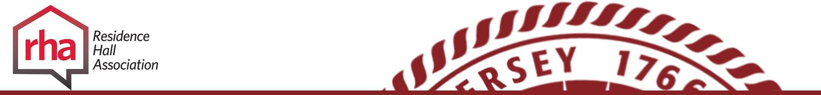 |  | Hall Government Checklist Prior to Info Session
MEETING OBJECTIVES:
☐ | Evoke excitement among the students about Hall Government
☐ | Provide residents with information about their role in their Hall Government
☐ | Communicate the purpose and election process of the Hall Government
PREPARATION:
☐ | Communicate with your President/VP/RHA rep about their role in the session
☐ | Consider if you would like a fun/social aspect (ice breaker, activity, food, etc.)
☐ | How do you want to communicate the information – Powerpoint, posters around the room describing each position or listing benefits of being in Hall Government, etc.
☐ | Consider how you want to collect student information (name and email) – writing on a sign-up sheet, typing into a spreadsheet on an iPad, etc.

Hall Government Info Session Agenda
INTRODUCTION
☐ | Introduce yourself and any staff that is present and have each person talk about their roles
☐ | Collect information from students who attended (name and email) so you can follow up with them later (add this to the names from the Move In sign-up sheet)  - Compare this information to your sign up’s on opening day and follow up with students who missed the meeting (Your RA staff should be able to help with this).
☐ | Option: Fun ice breaker
☐ | Discuss what RHA and Hall Government is. Talk about programming, community development, advocacy, voice for the students, leadership opportunities, relationships, getting you connected to students across your hall and campus, make a difference at the campus & university level, resume builder, leadership experience  - Include history (2007), traditions (LDD, conferences), mission statement & anything else important
STRUCTURE OF YOUR INDIVIDUAL HALL GOVERNMENT:
☐ | Executive Board positions (President, VP, Secretary, Treasurer, External Relations Chair, Event Coordinator, Advocacy Liaison)
☐ | Role of additional positions (if applicable – ex: floor reps, birthday chair, etc.)
☐ | Role of the Hall Government General Assembly (General Floor Reps, student attendees)
☐ | General expectations of members: Year Long Commitment. As a group you’ll meet weekly, Pres/VP will meet additionally with the advisor once a week, attendance at programs throughout the year, LDD, upholding your specific responsibilities, etc.
☐ | Also, EVERYONE can show up to meetings and be a general member ☺
ELECTION PROCESS IF YOU WANT TO RUN FOR A POSITION
☐ | Applications due: September 17th
☐ | Advertising materials must be approved by the advisor  ☐ Discuss where advertising can and cannot be posted. No door to door soliciting, handing people tablet/laptop, etc. Review election guidelines on rha.rutgers.edu
☐ | Online voting will occur from September 20th-22nd
☐ | Winners will be announced on September 25th
☐ | Running for an additional position? Discuss your hall process
FINAL THOUGHTS
☐ | Talk about why students should get involved, talk about your experience within RHA
☐ | Discuss what Leadership Development Day. This will occur on October 7th.
☐ | Make sure everyone has signed in
☐ | Questions?
Advising Do’s
- Assist members with procedural matters and help them set goals. Be knowledgeable of the organization’s purpose and constitution and help the general membership adhere to them.
- Be knowledgeable about and help the group make sure they’re complying with Residence Life policies. Also, serve as an overall campus resource.
- Develop clear expectations about the role of the advisor to the organization.
- Discuss concerns with members in private and praise them in public.
- Help orient new members.
- Help to resolve intragroup conflict.
- Help to develop the leadership potential within the group.
- Be visible, attend group meetings and events, triage issues as they arise.
- Help students find a balance between activities and their academic responsibilities.
- Share creative suggestions and provide feedback for activities planned by students.
- Keep an eye on the budget to make sure the group does not overspend and answer questions the Treasurer might have.
- Learn the strengths and weaknesses of the group. Offer support when necessary; but also allow people to make their own mistakes and learn from them.
- Provide support. Give the group autonomy but offer feedback, even when it is not solicited. Let the group work out its problems, but be prepared to step in when called upon to assist.
Advising Don’ts
- Be a know it all.
- Be the leader or “run” the meeting.
- Say I told you so.
- Impose your own bias.
- Manipulate the group, impose, or force your opinions.
- Tell the group what to do, or do the work of the President or other members of the E-board
- Take everything so seriously.
- Take ownership for the group, be the “parent,” or the smothering administrator.
- Miss group meetings or functions.
- Be afraid to let the group try new ideas.
- Become such an advocate that you lose an objective viewpoint.
- Allow the organization to become a one-person organization.
- Assume the group handles everything okay and doesn’t need you.
- Assume the organization’s attitudes, needs and personalities will remain the same year to year.
Some information adapted from Schreiber, V. and Pfleghaar, E. “Supervising vs. Advising”, UMR-ACUHO, 1999
Motivating Others
- Provide opportunities for others to make a real contribution to the group
Let people come up with their own tasks to accomplish or delegate jobs that match each person’s skills and interests. It is not motivating for someone to simply admire what you, the leader, has accomplished. Give others the same opportunity that you value: to gain satisfaction and pride in their results.
- Acknowledge the accomplishments of others frequently and publicly
Most people thrive on public recognition, but few will ask for it by announcing what they’ve done. By announcing for them, and giving the converted pat on the back, you will motivate them to accomplish even more.
- Keep everyone informed of what’s happening
Remind yourself that others might feel out of the loop if they don’t know what’s going on or what the game plan is. An effective leader never gets too far ahead of the pack.
- Actively solicit and actively listen to others’ suggestions and concerns
People want to be heard; they are motivated by the opportunity to contribute an idea. Remember, mutual respect and understanding are keys.
- Foster a sense of belonging
This makes people feel secure and committed to the group and the group’s goals. Develop a shared vision and group cohesiveness centered around that vision.
- Develop their commitment to you by showing your commitment to them
People want to look to you for inspiration and empowerment. They want you to motivate them without manipulating them. They want to know that you like them, respect them, understand them, and accept them for who they are, not as a means to your end. Help develop them.
- Give people good reason to trust you
Be fair and stick to your word. People must see that you have integrity and a set of values they can depend on. Unethical conduct, favoritism, covert operations, and dishonesty never motivate people to higher achievement.
- Provide honest feedback
Honesty (NOT being judgmental) is usually appreciated when accompanied by helpful suggestions for improvement. Don’t forget that positive feedback and encouragement motivate people to achieve even greater results.
- Be there for people.
Remember, give them what they want and need, and they will motivate themselves to give you what you want for the group and for yourself.

Retention of Members
Retention is essential to the continuation and stability of a Hall Government. As an advisor, you must be aware of the needs of your Hall Government members and work towards reaching those needs and exceeding them. Keep members involved and encourage their growth within the organization as well as both professionally and personally.

Tips for retention:

People Need to Feel Important
See people as worthwhile human beings loaded with untapped potential; go out of your way to express this attitude.
Give Praise
Reinforce for continual achievement. All people need praise and appreciation. Get into the habit of being “praise-minded.” Give public recognition when it is due.
Give People Status
The more status and prestige you can build into a committee or an organization, the more motivated the members become. There are many status symbols you can use to make others feel important. For example, develop a “Member of the Week/Month” Award or “Committee Chairperson of the Month” Award. In addition, simply treating people with courtesy is a way of giving them status.
Communicate
People like to know what is going on in the organization. They want to be told about problems, objectives, and “inside information.” They feel recognized and important when they are kept informed. Two-way communication within the organization is necessary in order to achieve a mutual understanding. Mutual understanding leads to motivation!
Develop Purpose
Always explain why. Instill in the members that their assistance is vital for success. Share ways that participation can encourage personal growth.
Encourage Participation in Group Goal Development
Include all members when planning goals. Consider and follow through on members’ suggestions. Remember that we support that which we help to create.
Develop a Sense of Belonging
People like to belong. Those who feel like they belong will more likely invest themselves.
Group Development and the use of Tuckman

Forming:
- Develop ice breakers to help the members become acquainted
- Coordinate a retreat or workshop for the Eboard or all of the members
- Review the organization’s mission, purpose, and history
- Identify expectations
- Have weekly meetings with the President and Vice President to check-in and prepare them for leading in their roles
- Discuss effective meeting management, planning programs, and team building with the Eboard
- Provide an initial to-do list and assistant them in beginning their duties
Storming:
- Provide mediation resource when conflicts become difficult to manage
- Teach confrontation and communication skills to the Eboard and other members
- Review the mission statement, purpose, and expectations if necessary
- Conduct a group decision-making activity
- Develop a “rebuilding” team activity
- Remind everyone that the storming stage is a natural part of group formation

Norming:
- Schedule a more in-depth team builder that includes greater self-disclosure
- Develop T-shirts, logos, group slogan, etc. to help with identity formation
- Assist the group in starting a new program that will create a tradition
- Review and possible establish new goals for the organization
- Maintain Eboard and member relationships so as to avoid reverting back to the storming stage

Performing:
- Ensure that the organization and members have specific tasks and goals
- Give feedback and discuss what could be improved upon later or next year
- Step back and allow the organization to perform

Adjourning:
- Develop a closure activity to reflect on what was learned
- Conduct an assessment or evaluation of the year (ex: transition reports)
- Plan an end of year recognition activity or gift, or banquet
- Encourage members to keep being involved the subsequent year if possible
- Ensure records are properly stored and maintained for the following year
Important Events

Throughout the year, these are several important events that all hall government members should be aware of. Listed are these events and brief descriptions of them. Where available, the dates and locations of each event is included.

Fall Leadership Development Day
Saturday October 7, 2017
Douglass Campus – Student Center

Each hall government member is trained in order to effectively complete their duties throughout the year. The event is coordinated by the Director of Leadership Development and each session is conducted by members of the Executive Board. Sessions focus on topics such as how to successfully navigate each position, conflict management and resolution, and goal setting.

CAACURH Regional Leadership Conference
Friday November 3 – Sunday November 5, 2016
University of Maryland, Baltimore County

Representatives of Rutgers RHA and NRHH will attend the Central Atlantic Affiliate of College and University Residence Hall Regional Leadership Conference. The Rutgers delegation will be selected by the National Communications Coordinator by the middle of October. Conference delegates will have the chance to interact with RHA members from other schools throughout the CAACUH Region and take back the information they learned to the university.

Spring Leadership Development Day
Saturday January 27, 2017
Douglass Campus – Student Center

In order to maintain the motivation of hall government members throughout the Spring Semester, Spring Leadership Development Day is a follow up leadership development day that focuses more on Student Leadership Development in general rather than position specific training. It allows hall governments to regroup and continue to be effective throughout the Spring Semester
CAACURH Regional Business Conference (“No Frills”)
Friday February 9 – Sunday February 11, 2017
Rowan University

The “No Frills” Regional Business Conference is a conference specifically for the RHA President, NRHH President, and the National Communications Coordinator. During the conference members discuss and debate different pieces of legislation and view different bids for Regional Board positions and regional conferences.
End of the Year Banquet
Friday May 2, 2016

The End of Year Banquet aims to recognize the contributions that hall government members have made throughout the year, First Year Student Leader of the Year, General Assembly Member of the Year, Scarlet Pride Pins, and many other awards will be given out at the banquet.

NACURH Annual Conference
Friday May 26 – Sunday May 28 2017
Arizona State University

The National Association of College and University Residence Halls Annual Conference will be held at Arizona State University. The Rutgers delegation will be selected by the National Communications Coordinator through an application process, similar to the CAACURH conference application process. The delegation will represent Rutgers to approximately 2500 student leaders from approximately 400 colleges and universities from across the nation and internationally. The Rutgers delegation will be able to share information they have learned with other members of the Rutgers Community.

National Residence Hall Honorary

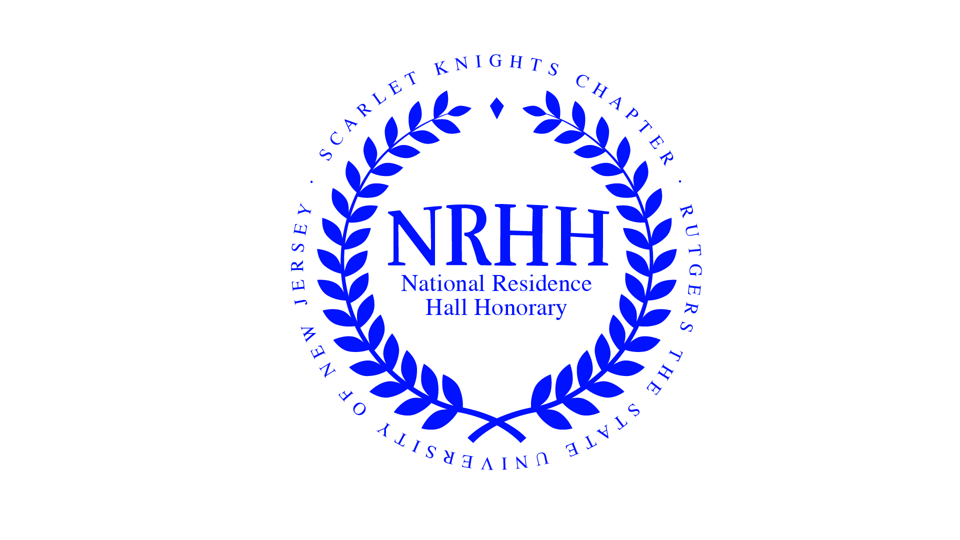
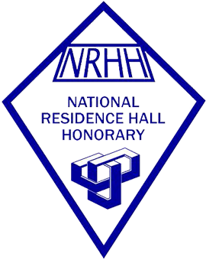

What is National Residence Hall Honorary (NRHH)?
NRHH is a national honorary dedicated to recognizing those individuals and entities who work to improve their residence hall, campus, and/or community. Their core values are SERVICE and RECOGNITION.

NRHH Mission Statement:
The mission of the Scarlet Knight’s Chapter of NRHH is to recognize the top 1% of student leaders living on campus through the NRHH pillars of Leadership, Recognition, Community Service, and Scholarship. NRHH aims to promote involvement and community within Rutgers University and within the greater New Brunswick/Piscataway area.

Who can become a member of NRHH?
Any on-campus student who plans to reside in a university residence hall for at least one semester (following application for membership) can be an active member of NRHH. The student must have lived in the residence halls for at least one semester prior to induction (therefore new students will not be eligible until their second semester). The student must demonstrate outstanding leadership, service, and dedication to making a positive impact within the residence halls. Furthermore, the student must also maintain a cumulative GPA of 2.75 or higher.
Note: Nominations and applications occur each semester.

4 Different Types of Membership
Active: Current undergraduate and graduate students living on campus who meet the GPA and other membership requirements seen above (they have voting privileges)
Honorary: Faculty, staff, housing personnel, seniors who are graduating, students who do not meet the GPA requirement, etc. (no voting privileges)
Alumni: Members who moved off campus or graduated (they can still be involved, no voting privileges)
Early Alumni Membership Status (EAMS): Inducted into an affiliated NRHH Chapter, but can no longer fulfill activity level of chapter

Organization Composition:
The organization is comprised of six Executive board members. The four directors each lead their own committee in which general members partake (Membership, Recognition, Service, and External Affairs).
Executive Board 2017-2018
President – Ashley Xinyi Huang
Vice President – Jennifer Jiang
Director of Membership – Samantha Douglas
Director of Recognition – Nick Lee
Director of Service – Nadia Fazel
Director of External Affairs – Chanina Wong
What all does NRHH do?
- Community service projects
- Recognition programs
- Of the Month Awards (OTMs)
- Campus-wide programs
- Induct members into the Honorary
- Leadership retreats
- Conference attendance
- Serve the community in many other ways

Expectations for supporting NRHH- National Residence Hall Honorary
1. Assist with membership and recruitment by submitting letters of recommendation to NRHH recommending student for the organization.
2. Speak to students about NRHH and the opportunities the organization has. Provide this information to RA/AAs, at floor meetings, through bulletin boards etc.
3. Support NRHH through attendance at their programs and events throughout the year including their service and recognition events.
4. Post NRHH bulletin boards, flyers, recruitment information in your hall/space
5. Write OTMS’s(Of The Month) nominations each month ask staff and students to as well once a month/once a semester
6. Attend NRHH’s three large events of the year, their fall and spring induction ceremonies and their OTM Banquet in the spring semester
7. Attend the End of the Year RHA/NRHH Banquet

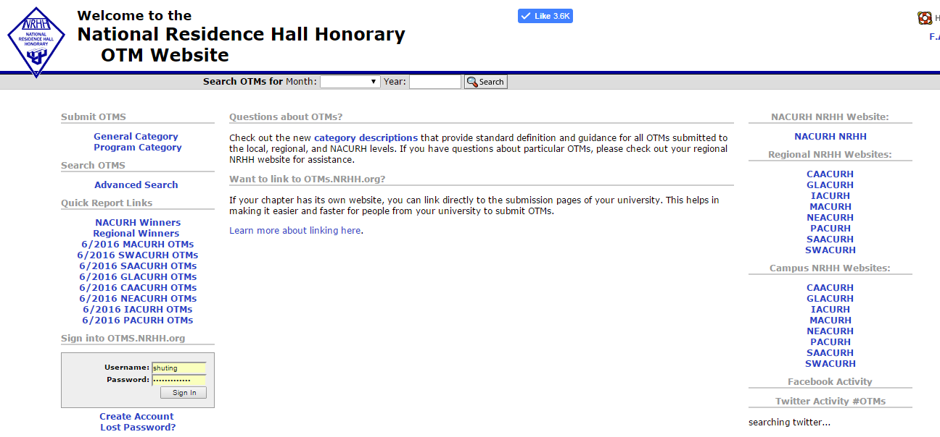
http://otms.nrhh.org/

How to submit an OTM
- Determine who (RA/AA, resident, RHA member, etc.) or what program (service, diversity, educational, social, passive) you want to recognize
- Go to http://otms.nrhh.org and select a category: General (people, organizations, communities) OR Program (there are 5 different types)
- Fill out the contact info (Note: nominees get notified of their nomination)
  - For both nominee/nominator fill out at least the first/last name, email, and residence hall
  - In a program OTM, the nominee is the person in charge
- Make the nominee/program shine in all the answers. Write from the heart. It can take some time to write a good quality OTM, but the voting committee wants to know what the nominator finds deserving of the OTM.
Questions? Feel free to contact the Director of OTMs at runrhhrecognition@gmail.com

