National Residence Hall Honorary
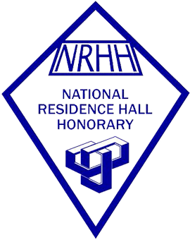

Expectations for supporting NRHH- National Residence Hall Honorary
1. Assist with membership and recruitment by submitting letters of recommendation to NRHH recommending student for the organization.
2. Speak to students about NRHH and the opportunities the organization has. Provide this information to RA/AAs, at floor meetings, through bulletin boards etc.
3. Support NRHH through attendance at their programs and events throughout the year including their service and recognition events.
4. Post NRHH bulletin boards, flyers, recruitment information in your hall/space
5. Write OTMS’s(Of The Month) nominations each month ask staff and students to as well once a month/once a semester
6. Attend NRHH’s three large events of the year, their fall and spring induction ceremonies and their OTM Banquet in the spring semester
7. Attend the End of the Year RHA/NRHH Banquet

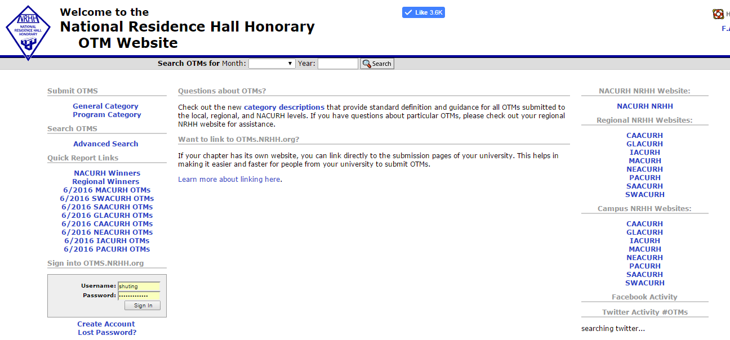
http://otms.nrhh.org/

How to submit an OTM
- Determine who (RA/AA, resident, RHA member, etc.) or what program (service, diversity, educational, social, passive) you want to recognize
- Go to http://otms.nrhh.org and select a category: General (people, organizations, communities) OR Program (there are 5 different types)
- Fill out the contact info (Note: nominees get notified of their nomination)
  - For both nominee/nominator fill out at least the first/last name, email, and residence hall
  - In a program OTM, the nominee is the person in charge
- Make the nominee/program shine in all the answers. Write from the heart. It can take some time to write a good quality OTM, but the voting committee wants to know what the nominator finds deserving of the OTM.
- Questions? Feel free to contact the Director of OTMs at runrhhrecognition@gmail.com

